**AICT003-4-2-NWN: Networks and Networking**

**Tutorial Activity: IP Addressing (Subnetting-VLSM)**

**Instructions:**

1. You have been given the 192.168.15.0/24 address space to use in your network design. Prepare the IP addressing plan for the network (with subnetting/VLSM) and show the detailed calculation of subnet mask. Refer to the attached table and fill in the blanks with suitable addresses.

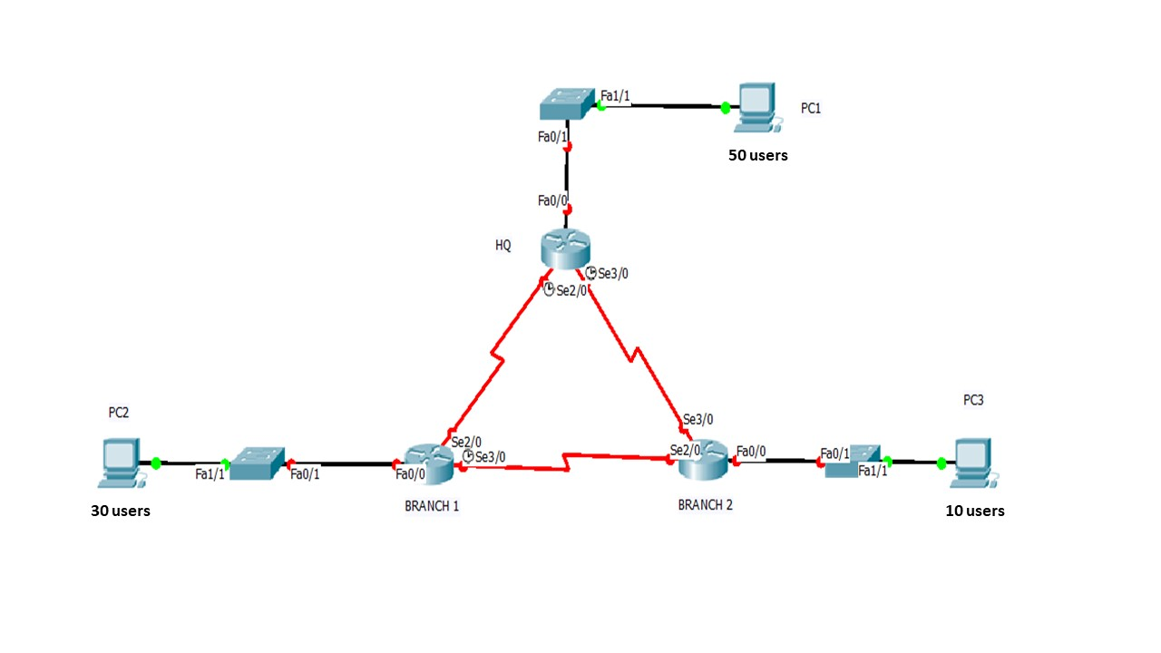

Figure 1: Topology Diagram

| Device | Interface | Network Address | IP Address | Default Gateway |
| --- | --- | --- | --- | --- |
| HQ | Fa0/0 | 192.168.15.0 / 26 | 192.168.15.1 | N/A |
| Se2/0 | 192.168.15.112/30 | 192.168.15.113 | WAN 1- N/A |
| Se3/0 | 192.168.15.116/30 | 192.168.15.117 | WAN 2- N/A |
| BRANCH 1 | Fa0/0 | 192.168.15.64/27 | 192.168.15.65 | N/A |
| Se2/0 | 192.168.15.112/30 | 192.168.15.114 | N/A |
| Se3/0 | 192.168.15.120/30 | 192.168.15.121 | WAN 3- N/A |
| BRANCH 2 | Fa0/0 | 192.168.15.96/28 | 192.168.15.97 | N/A |
| Se2/0 | 192.168.15.120/30 | 192.168.15.122 | N/A |
| Se3/0 | 192.168.15.116/30 | 192.168.15.118 | N/A |
| PC1 | NIC | 192.168.15.0/26 | 192.168.15.2 | 192.168.15.1 |
| PC2 | NIC | 192.168.15.64/27 | 192.168.15.66 | 192.168.15.65 |
| PC3 | NIC | 192.168.15.96/28 | 192.168.15.98 | 192.168.15.97 |

Draw this diagram using Cisco Packet Tracer and configure the IP Address and Routing accordingly.

Routing can be configure using static and RIP version 2 routing.